Non-places of Virtual Reality and Spatial Practice

Hyungjin Jeon¹, Hongsik Pak², Taesoo Yun³ and Eeljin Chae^{4*}

Department of Visual Contents Graduate School Dongseo University¹
Department of Digital Contents Donseo University^{2, 3, 4*}
Jurye-Ro 47, Sasang-Gu
Busan 47011, Korea
h01086090095@gmail.com¹, {hspak², tsyun³, cinetree^{4*}}@dongseo.ac.kr

Abstract

Virtual reality space based on head-mounted display demonstrates the concept of ‘non-places’as put forward by Marc Auge. Spatial practice in virtual reality space which offers visual reality is delivered through the ‘act of seeing.’ Here, spatial cognition, experience and interaction enables sensory metastasis. Spatial practice in Virtual reality space results in interaction and experience based on the process of visual cognition. Also, it gives sense of reality and existence to facilitate contents immersion.

keywords: Head Mounted Display, Virtual Reality Space, Non-places, Immersion and Presence

I. Introduction

Advancement in digital technology and various media has led to the increasing importance of virtual reality space beyond the conventional notion of physical space. Virtual Reality(VR) space, where visual reality takes precedence, the user interacts with the space through visual cognition.
As such, VR space which is based on head-mounted display (HMD) can be considered to be a place, following Marc Auge’s concept of ‘non-places’ which is formed through the conditions of supermodernity and digital network technology society. In this ‘non-place’ of VR space, spatial action is accessible through visual behavior; VR space extends its significance through spatial cognition and user experience.

II. Non-places and Spatial Practice

A. non-places

In Marc Auge’s notions of place and space, ‘place’ is defined through relationship and history and relates to identity; ‘space’ does not, which is why it’s considered ‘non-place.’ Here, ‘non-places’ are not anthropological places which lack symbolic expressions of identity, relationship and history; rather they exist on the basis of supermodernity – a feature of modern, technological society. It’s not a place for staying; it includes network-based space for passing by. This is confirmed in that social network services (SNS) space on mobile media is considered a ‘non-place.’
Thus ‘non-space’ is characertised for its circularlity, passage, occupation and connection which allows for temporary and contract-based staying and communication. HMD-based VR space allows for network connection, combining device and contents, from a physical place to digital space, wherever the user may be; thus it is considered a ‘non-place.’ [1-5]

TABLE I
Auge’s Non-Places and Places

Non-Places | Places
Transit | Residence
Interchange | Crossroads
Passenger | Traveler
Housing estate | Monument
Communication | Language

B. Spatial Practice

Michel de Certeau called space ‘practiced place;’the importance of story created through the act of walking in space was emphasized. Here, the ‘act of walking’ relates the user who experiences the space with that space through the practice; the user and space influence each other.
Given that de Certeau focuses on how the ‘act of walking’ reads and interprets space, the process of visually understanding space can develop in the the process of spatial cognition and interaction. The sensory experience of congition through the ‘act of seeing’ expands space and leads to a renewed understanding. This experience causes the emotions felt by the agent who experiences the space to expand into cogntivie and perceptual elements; their significance is thus expanded in sensory terms, resulting in the expansion of space. This is what enables spatial practice based on interaction with and understanding of space.
VR space which exists through digital media takes on the characteristics of multimedia based on data such as text, image and sound. To become aware of such space, visually perceived image and the symbolism of text must interact with individual experience to merge into a single symbolism. [3, 6]

C. VR and Spatial Practice

The concept of ‘non-places’ as physical space is defined by words or text. The ‘non-places’ of daily life and experience, ‘passing point’ or ‘temporary residence,’ are places which we move to spatially in order to fulfil objectives. What connects the individual with the environment, other than relationship formed with the particular purpose of place, is language and image created by it.
If this concept of ‘non-places’ can develop to be defined by media symbols, VR space, which can be defined as spatial movement by digital nomad, may be termed a space with its own purpose, isolated from the real world. If VR space is seen not as residential space but rather space of transit and movement, thus a ‘non-place,’ then the newly created reality and spatial practice in VR space merit our attention.
SNS space, a virtual ‘non-places’ of mobile media, can be seen through text, photos and video; on the other hand, VR space can be visually received through 360-degree video. Here, the notion of walking, which includes visual perception and cognition of it, can be integrated with the act of moving. The act of seeing, visually understanding and recognizing space for experience in VR purports to acquire spatial information and to explore the space; this is the process of spatial practice in VR space. In other words, sensory metastasis occurs from virual space. Such sensory action of the user’s experience imbues VR space with the significance as space for the user; and the need for spatial formative design considering user experience can be explained. [7-9]

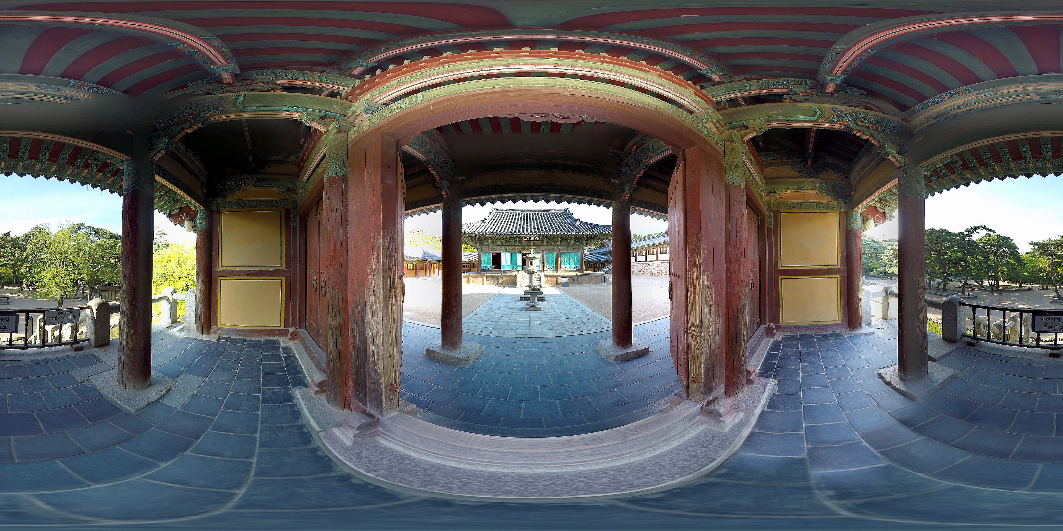

Fig. 1 VR Space: Geukrakjeon, Bulguksa Temple

III. Conclusion

In the process of visual recognition of real space, humans visually perceive landmarks, routes and selection points along with graphic elements such as colour, size and form. These are then integrated with individual experience to understand and experience the space. In VR space, there is complete visual freedom. This is why UI and visual direction are needed to inform the user who seeks to experience VR space through the ‘act of seeing.’
Experience in VR space transforms the space of observation into the space of experience. ‘Seeing’ is entering and immersing oneself into that virtual space for cognition; the act of paying attention can develop into the idea of residing in that space. [10] This ultimately is a development from seeing to being. Spatial practice in VR space results in interaction and experience based on visual perception. Also, interaction and understanding of sensory space based on user experience endows a sense of reality and existence, enabling contents immersion.

References

[1] A. Marc, “Non Places: An Introduction to Supermodernity,” London: Verso, 1995.
- J. D. Bolter and L. Grusin, “ Remediation: Understanding New Media,” MA: MIT Press, 2000.
- A. N. Mun, “Mobile Media and Spatial Practice,” The Korean Journal of Art and Media, vol. 15, no. 1, pp.133-160, February 2016.
- H. J. Jung, “The Place of Urban Architectural Space of Mobility in Marc Auge’s ‘Non-Place’,” Journal of the Architectural of Korea Planning & Design, vol. 31, no. 3, pp. 131-142, March 2015.
- M. Y. Kim, J. Y. Kim, Y. S. Hwang, “A Study on experientially-based understanding of place of Transmission Digital 3D Image Media,” Journal of Korea Institute of Spatial Design, vol. 10, no. 5, pp. 125-138, October 2015.
- S. H. Lee and S. Y. Shin, “Transference from Physical space to sensorial space,” The Korean Journal of Art and Media, vol. 14, no. 2, pp.55-74, May 2015.
- J. H. Kim, E. K. Cho, Y. S. Ban, “A Studyon Observation Type at the Process of Visual Understanding,” Korean Institute of Interior Design Journal, vol. 21, no. 2, pp. 92-100, April 2012.
- T. W. Park, “Study on Percipient’s Cognitive Reaction of Spatial Formative Elements,” Bulletin of Korean Society of Basic Design & Art, vol. 17, no. 1, pp. 245-256, January 2016.
- H. H. Park, “A Study on visual Perception for effective motion graphics,” Design Convergence Study, vol. 12, no. 4, pp. 115-128, August 2013.
- M. M. Ponty, “Phenomenologie de la Perception.” London: Routledge, 1998.

